CSEE 120A Fall 2018
Midterm
Kelly Downey

Exam Rules:
● Do not open the exam until instructed to do so.
● Once you start the exam, please write your name and netID on the top of all pages.
● Once the exam has started, you are not able to leave the room. If you leave the room, your exam is over.
● Please remove all hats, watches, and sweatshirt hoods.
● Turn electronics off and store in your backpack.
● The exam is open notes.
● Please write legibly.
● Proctors are not allowed to answer clarification questions. You may write any assumptions you make on the exam. They may or may not be considered for grading.
● If you find an error on the exam, please inform a proctor.
● When you are finished with the exam, you may bring it to a proctor. Please show your student ID.
● I would wish you good luck, but, you don’t need it. You’ve got this!

1. (4 points) Create the truth table for the gate below. Draw the corresponding timing diagram.
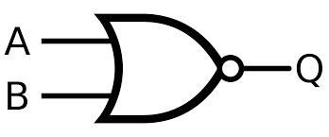

2. (4 points) Draw the circuit for the equation below.
y = abc + cb'a

3. (4 points) Given the following truth table with inputs a b and c and output y, find the simplified equation using a K-map.

a b c y

0 0 0 0

0 0 1 0

0 1 0 0

0 1 1 1

1 0 0 0

1 0 1 1

1 1 0 1

1 1 1 1

4. (4 points) Given the following equation, find the simplified equation using boolean algebra. Write final equation in sum-of-products form.

F = a’b( c + d’) + a(b’ + c) + a(b + d)c

5. (9 points) Consider a candy dispensing machine. Each candy cost 75 cents. The user puts only quarters into a slot that triggers a signal, a, to go high for one clock cycle. When the user has inserted three quarters, a signal, q, will be set high for one clock cycle to release the candy bar. Create a finite state machine for the candy dispensing machine. Assume that the user will always enter three quarters and there is no reset button. Then, create the truth table describing the state machine.

